The Scientific Revolution & The Enlightenment

AP Euro Homework Assignments

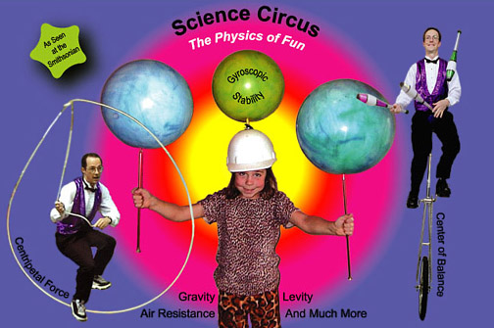{Section 32-40}

DATE: 1/16/14

TOPIC: Exam – Chapter 4-6

1. Essay and Multiple Choice Exam.

HOMEWORK:

1. P/C pp. 265-271: Section 32

(Prophets of a Scientific Civilization: Bacon and Descartes)

DATE: 1/17/14

TOPIC: "I think, therefore I am…"

1. Small group discussion and debriefing.
2. Lecture on Bacon and Descartes.

HOMEWORK:

1. P/C pp. 271-280: Section 33

(The Road to Newton: The Law of Universal Gravitation)

_________________________________________________________________________________________

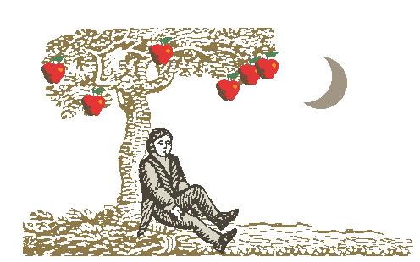DATE: 1/21/14 – Early Dismissal

TOPIC: "The Road to Newton"

1. Discuss questions.
2. Lecture on The Road to Newton.
3. Watch Newton Video with study guide.

HOMEWORK:

1. P/C pp. 280-287: Section 34

(New Knowledge of Human Beings and Society)

1. P/C pp. 288-293: Section 35

(Political Theory: The School of Natural Law)

________________________________________________________________________________________

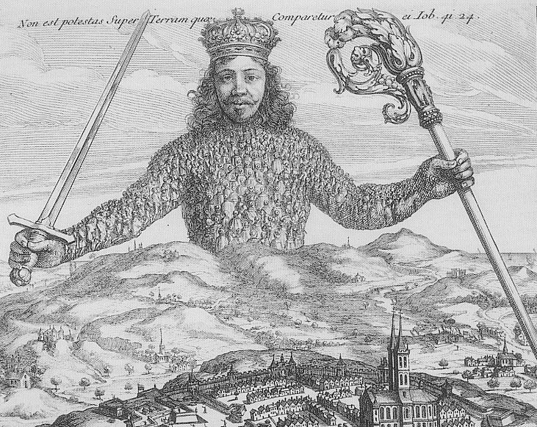DATE: 1/22/14 – No School

---------------------------------------------------------------------------------------------------------------

DATE: 1/23/14

TOPIC: "New Knowledge?"

1. Lecture on Skepticism.
2. Search for Meaning WS
3. Lecture on Hobbes & Locke
4. Apply reading to discussion

HOMEWORK:

1. Study for quiz tomorrow: Bacon, Descartes, Newton, and New Knowledge.

________________________________________________________________________________________

DATE: 1/24/14 – ½ Day Schedule : FULL 2nd Block

TOPIC: "'New School Absolutism' v. 'New School Constitutionalism'"

1. Chapter 7 Quiz.
2. Lecture on the philosophes and physiocrats.
3. Old vs. New Order Worksheet
4. Explanation of assignment, selection of groups, and assignment of philosopher.

HOMEWORK:

1. P/C pp. 295-301: Section 36

(The Philosophes – and Others)

1. P/C pp. 301-317: Section 37

(Enlightened Despotism: France,Austria,Prussia)

_________________________________________________________________________________________

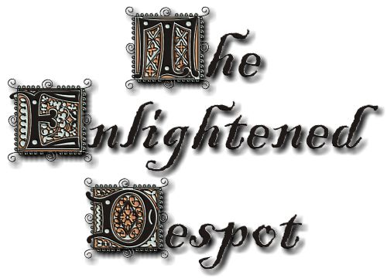DATE: 1/28/14

TOPIC: “Enlightened Despotism: France, Austria, Prussia, Russia”

1. Small Group Discussion and Debriefing
2. Old vs. New Order Worksheet
3. Lecture on Enlightened Despotism.
4. If time, create your own political cartoon

HOMEWORK:

1. P/C pp. 317-323: Section 38

(Enlightened Despotism: Russia)

________________________________________________________________________________________

DATE: 1/29/14

TOPIC: “Enlightened Despotism: Russia” & "The Great Enlightenment Salon”

1. Enlightened Despots - Russia
2. ½ Day in Library: Philosopher Research.

HOMEWORK:

1. P/C pp. 323-331: Section 39

(New Stirrings: The British Reform Movement)

1. P/C pp. 331-342: Section 40

(The American Revolution)

1. Salon on Monday!

_______________________________________________________________________________________

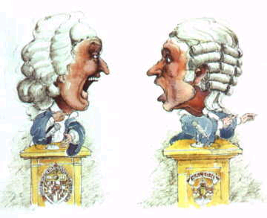DATE: 1/30/14

TOPIC: “English Reform & American Revolution”

1. Comparison of Enlightened Despots, if time
2. Lecture on the British Reform movement.
3. Debrief and Discussion on The American Revolution
4. Library Time – Salon Monday

HOMEWORK:

1. Enjoy a little school spirit at Red, White, and Blue Night

__________________________________________________________________________________________________

DATE: 1/31/14

TOPIC: “Enlightenment Salon Research”

1. Meet me in the library

HOMEWORK: Prepare for Monday’s Salon

______________________________________________________________________________________

DATE: 2/3/14

TOPIC: "The Great Enlightenment Salon "

1. Team prep and opposition question preparation.
2. Debate and debriefing.

HOMEWORK: Take Home Enlightenment Quiz – due Monday

­